Course 3 end-of-course portfolio project overview: TikTok

# Learn about the Course 3 TikTok workplace scenario!

The end-of-course project in Course 3 focuses on your ability to use exploratory data analysis to organize and understand the data within a project. As a reminder, in Course 1 you developed a project proposal that outlined milestones, which progress with each of the end-of-course projects. A visual representation is provided in the graphic shown here:

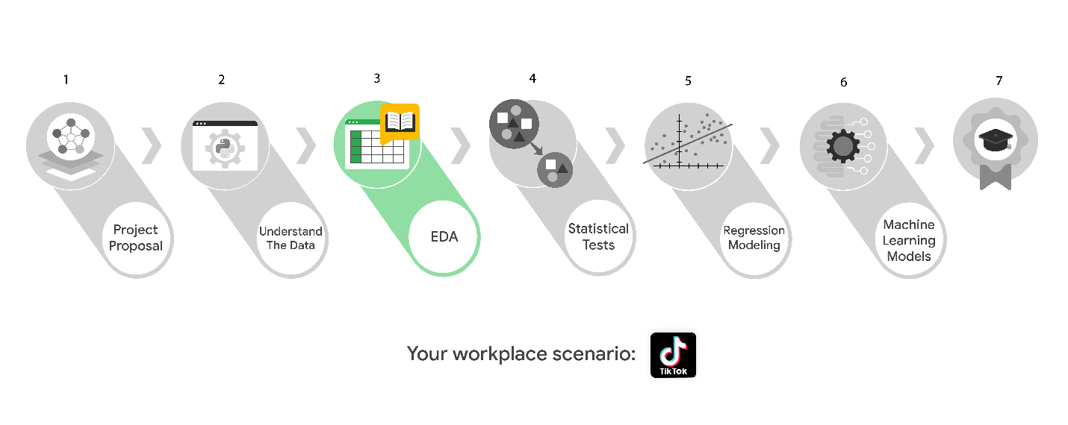

Learn more about the project, your role, and expectations in this reading.

# Background on the TikTok scenario

At TikTok, our mission is to inspire creativity and bring joy. Our employees lead with curiosity and move at the speed of culture. Combined with our company's flat structure, you'll be given dynamic opportunities to make a real impact on a rapidly expanding company and grow your career.

TikTok users have the ability to submit reports that identify videos and comments that contain user claims. These reports identify content that needs to be reviewed by moderators. The process generates a large number of user reports that are challenging to consider in a timely manner.

TikTok is working on the development of a predictive model that can determine whether a video contains a claim or offers an opinion. With a successful prediction model, TikTok can reduce the backlog of user reports and prioritize them more efficiently.

## Project background

TikTok’s data team is working on the claims classification project. The following tasks are needed before the team can begin the data analysis process:

* EDA and cleaning
* Select and build visualization(s) type
  + Create plots to visualize variables and relationships between variables
* Share your results with the TikTok team

## Your assignment

You will conduct exploratory data analysis on data for the claims classification project. You’ll also use Tableau to create visuals for an executive summary to help non-technical stakeholders engage and interact with the data.

# Team members at TikTok

## Data team roles

* Willow Jaffey- Data Science Lead
* Rosie Mae Bradshaw- Data Science Manager
* Orion Rainier- Data Scientist

The members of the data team at TikTok are well versed in data analysis and data science. Messages to these more technical coworkers should be concise and specific.

## Cross-functional team members

* Mary Joanna Rodgers- Project Management Officer
* Margery Adebowale- Finance Lead, Americas
* Maika Abadi- Operations Lead

Your TikTok team includes several managers, who oversee operations. It is important to adjust your general correspondence appropriately to their roles, given that their responsibilities are less technical in nature.

***Note:*** *The story, all names, characters, and incidents portrayed in this project are fictitious. No identification with actual persons (living or deceased) is intended or should be inferred. And, the data shared in this project has been created for pedagogical purposes.*

# Specific project deliverables

With this end-of-course project, you will gain valuable practice and apply your new skills as you complete the following:

* Course 3 PACE Strategy Document to consider questions, details, and action items for each stage of the project scenario
* Answer the questions in the Jupyter notebook project file
* Clean your data, perform exploratory data analysis (EDA)
* Create data visualizations
* Create an executive summary to share your results

# Key takeaways

The Google Advanced Data Analytics Certificate end-of-course project is designed for you to practice and apply course skills in a fictional workplace scenario. By completing each course’s end-of-course project, you will have work examples that will enhance your portfolio and showcase your skills for future employers.